**Experiment Title:** WAP in C++ to change the string contains A and B into a string such that there are no matching adjacent characters.

|  |  |
| --- | --- |
| **Student Name: Iram Nabi Dar** | **UID:19BCS3565** |
| **Branch: BE CSE** | **Lab Group:B** |

**Semester: 5th**

**Subject Name: Advanced Programming Lab Subject Code:CSP-347 Lab Worksheet: 3 Lab Group: 4**

1. **Aim/Overview of the practical:** WAP in C++ to change the string contains A and B into a string such that there are no matching adjacent characters. .
2. **Task to be done:**

WAP in C++ to change the string contains A and B into a string such that there are no matching adjacent characters.

**3. Algorithm/Flowchart (For programming based labs):**

**Step1:-Start**

**Step2:-Take an input of string.**

**Step3:-for (int i = 0 ; i < TakeInput.length() ; i++) { if (TakeInput[i] == TakeInput[i + 1]) {**

**counter++;**

**} else{**

**Textafter[j]=TakeInput[i]; j++;**

**}**

**}**

**Step4:- Print j for no.of same element.**

**Step5: Print Textafter[] for string after removing same adjacent character.**

**4. Steps for experiment/practical:**

**Step1:-Open Dev c++.**

**Step2:-Write program:**

**#include<bits/stdc++.h>**

**using namespace std;**

**int main() {**

**string TakeInput;**

**cout<<"Enter the Input :- ";**

**cin >> TakeInput;**

**char Textafter[10000];**

**int counter = 0;**

**int j=0;**

**for (int i = 0 ; i < TakeInput.length() ; i++) {**

**if (TakeInput[i] == TakeInput[i + 1]) {**

**counter++;**

**}**

**else{**

**Textafter[j]=TakeInput[i]; j++;**

**}**

**}**

**cout <<endl<<"The total number adjacent character same :- " <<counter << endl;**

**cout<<endl<<"The text after deletion of the same adjacent character :-";**

**int k=0;**

**for(k=0;k<=j+1;k++){**

**cout<<Textafter[k];**

**}**

**return 0;**

**}**

**7. Result/Output/Writing Summary:**

 **Screenshot show the output of program:-**

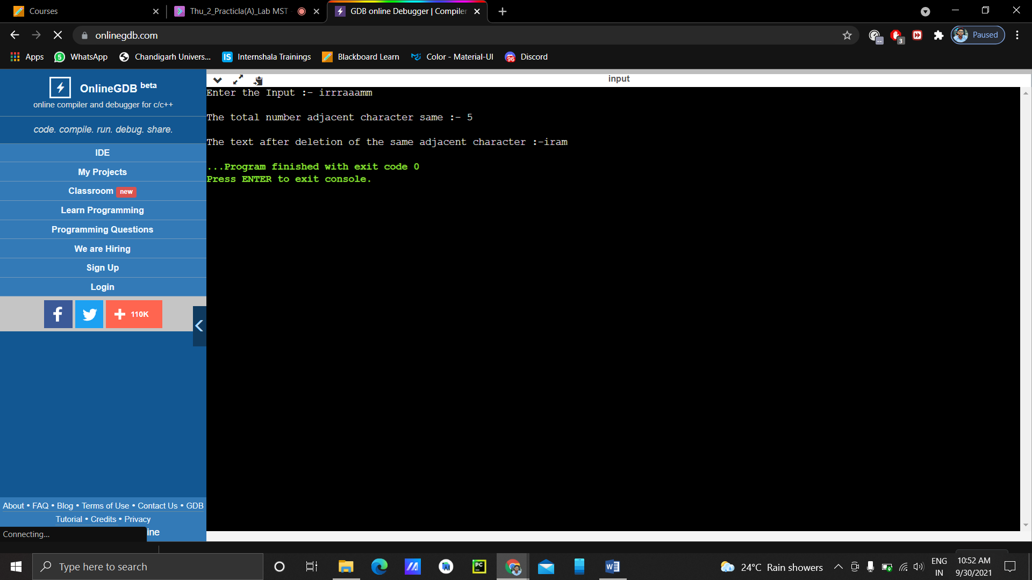

**Conclusion/ Remarks:**

**1.In this program we should learn about loop.**

**2.In this program we should learn about string.**

**3.In this program we should learn about character.**

**4.In this program we should learn about array.**

**5.In this program we should learn about combing array.**